***Power Saving Automatic Light Controller***

**User Manual**

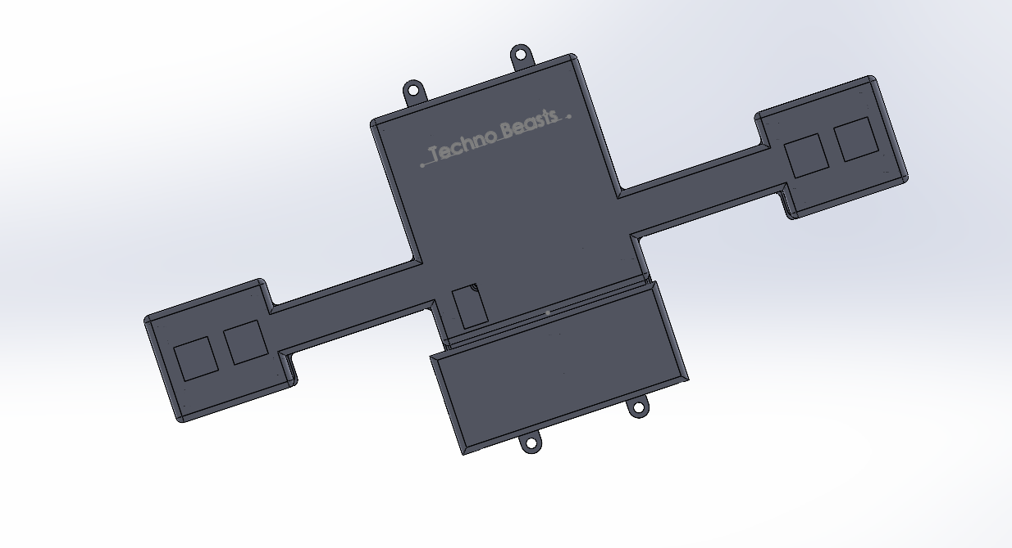

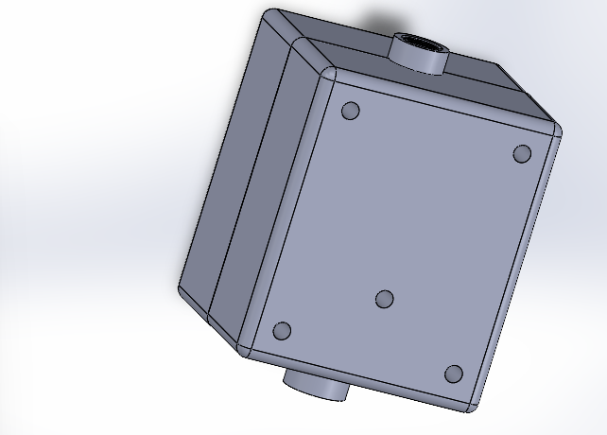

*Techno Beasts*

*Welcome to the user manual for the Power-Saving Automatic Room Light Controller. This device is designed to automatically control room lights based on occupancy, helping you save energy and reduce electricity bills. The two ultrasonic sensors detect movement within the room and trigger the lights to turn on or off accordingly*.

**Safety Instructions**

* Read this manual carefully before installation and operation.
* Ensure the power supply is disconnected before handling the device.
* Avoid exposing the sensors to direct sunlight or strong artificial light, as it may affect their performance.
* Keep the device away from water or other liquids to prevent electrical hazards.
* Do not tamper with the internal components; contact authorized service personnel for any repairs.

**Product Overview**

The Power-Saving Automatic Room Light Controller consists of the following components:

- Two Ultrasonic Sensors: Detect movement and occupancy within the room.

- Microcontroller Unit (MCU): Processes sensor inputs and controls the room lights.

- Relay Module: Controls the electrical connection between the light source and the power supply.

- Power Supply: Provides the required voltage for the device to operate.

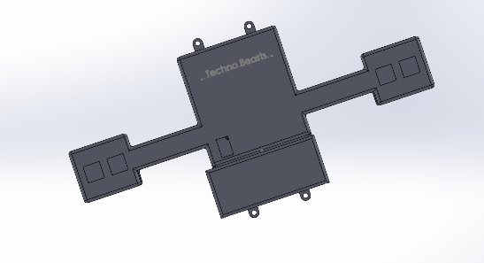**Installation Guide**

Part 1: Transmitter Installation

*Step 1: Prepare the Transmitter Unit*

* Unbox the transmitter unit.
* Fully charge the rechargeable batteries using the provided charging cable and a suitable USB power source.

*Step 2: Mounting the Transmitter Unit*

* Choose a suitable location on the wall or door where you want to install the transmitter unit. Make sure it has a clear line of sight to the area you want to monitor.
* Use screws or adhesive tape to securely attach the transmitter unit to the chosen surface. Ensure that the sensors face the area you wish to monitor.

*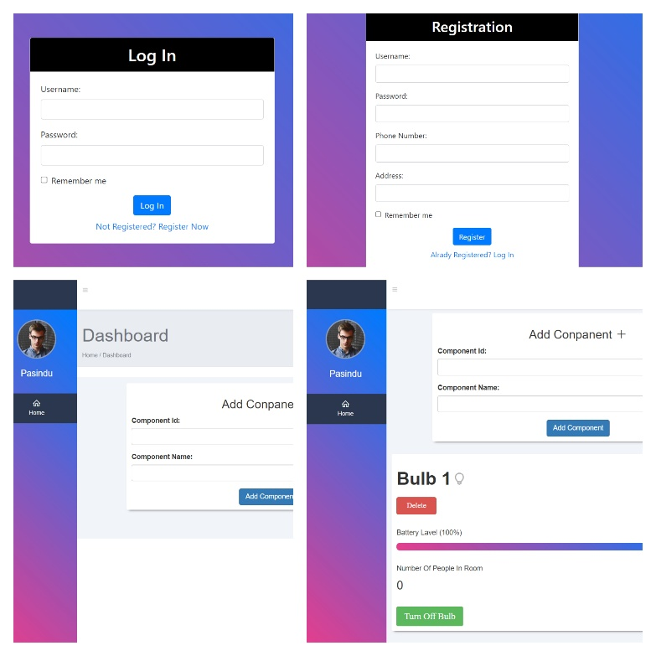Step 3: Connecting to the Web Interface*

* Turn on the transmitter unit using the power switch if available. The sensors will now start detecting motion.
* Connect your computer or smartphone to the Wi-Fi network.
* Open a web browser and enter the IP address or domain name (*https://technobeastsdata.000webhostapp.com/login.php*) then register to the site. After you log in enter the component ID which we are given and click Add Component button.
* Then you can see the battery level and number of people who are in the room.

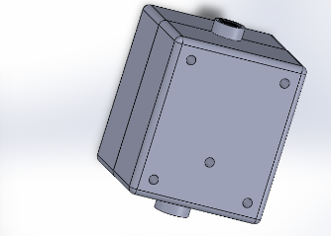Part 2: Receiver Installation

*Step 1: Prepare the Receiver Unit*

* Unbox the receiver unit and ensure all components are included: a suitable holder for installation.
* Check that the main power supply (230V) is available and easily accessible at the chosen installation location.

*Step 2: Mounting the Receiver Unit*

* Mount the receiver module inside the provided holder, making sure it is securely fixed.
* Connect the receiver unit to the main power supply (230V) using the provided power cord. Ensure proper electrical connections and safety.

*Step 3: Pairing the Transmitter and Receiver*

* Turn on the receiver unit by plugging it into the main power supply.
* On the web interface or application, initiate the pairing process to connect the transmitter and receiver units.
* Follow the on-screen instructions to establish a secure connection between the two units.

*Step 4: Testing the Automatic Room Light Controller*

* With the receiver unit powered on and the transmitter unit installed, walk into the monitored area to test the motion detection.
* Verify that the light turns on when motion is detected and turns off when the area is empty.

**Troubleshooting**

If you encounter any issues with the automatic room light controller, refer to the following troubleshooting guide:

* Issue: Lights do not turn on.
* Check the power supply and ensure it is connected and functioning correctly.
* Check whether the batteries are dead or not. If batteries are dead then you can charge the batteries or replace the battery.

**Maintenance**

To ensure optimal performance, perform the following maintenance tasks:

- Regularly clean the sensors' lenses to remove dust or dirt that may affect their sensitivity.

- Check all wiring connections periodically for signs of damage or loose connections.

**Technical Specifications**

* Operating Voltage: 7.4V (7V-12V)
* Installation: Wall mounted
* Sensor Type: Ultrasonic
* Detection Range: 4cm – 40m

**Warranty and Support**

The Power-Saving Automatic Room Light Controller comes with a year warranty. For any technical assistance or inquiries, please contact our customer support team.

Contact Details:

* +94 77 043 2076 – Pasindu
* +94 71 677 3542- Sandaru

*Congratulations! You have successfully installed and set up the Power-Saving Automatic Room Light Controller. Enjoy the convenience of automatic lighting control and the energy savings it brings. If you have any further questions or feedback, do not hesitate to contact our support team. Thank you for choosing our product!*